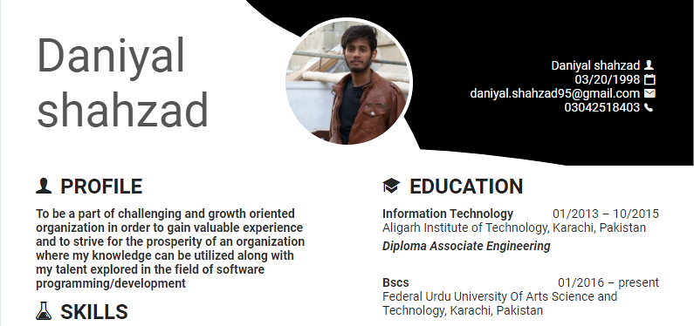

**Technical Skill**

**JAVA**

**HTML**

**Php**

**JavaScript**

**Jquery**

**C#**

**C++**

**Additional Skill**

**Project Management**



**Work Experience**

